## **Project “mfRPG” 1.5-Page GDD**

*Find out how to get back to your time and how did you end up here in first place.*

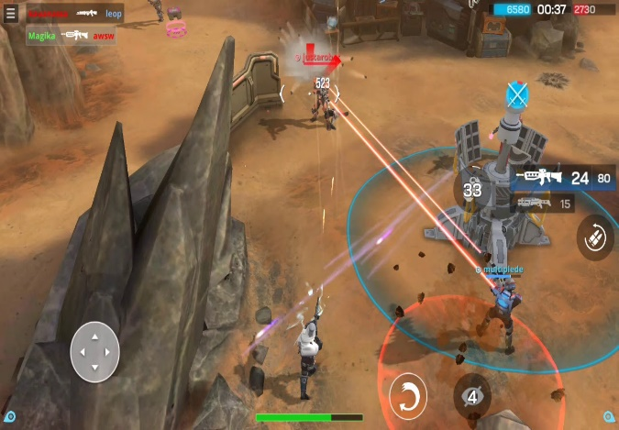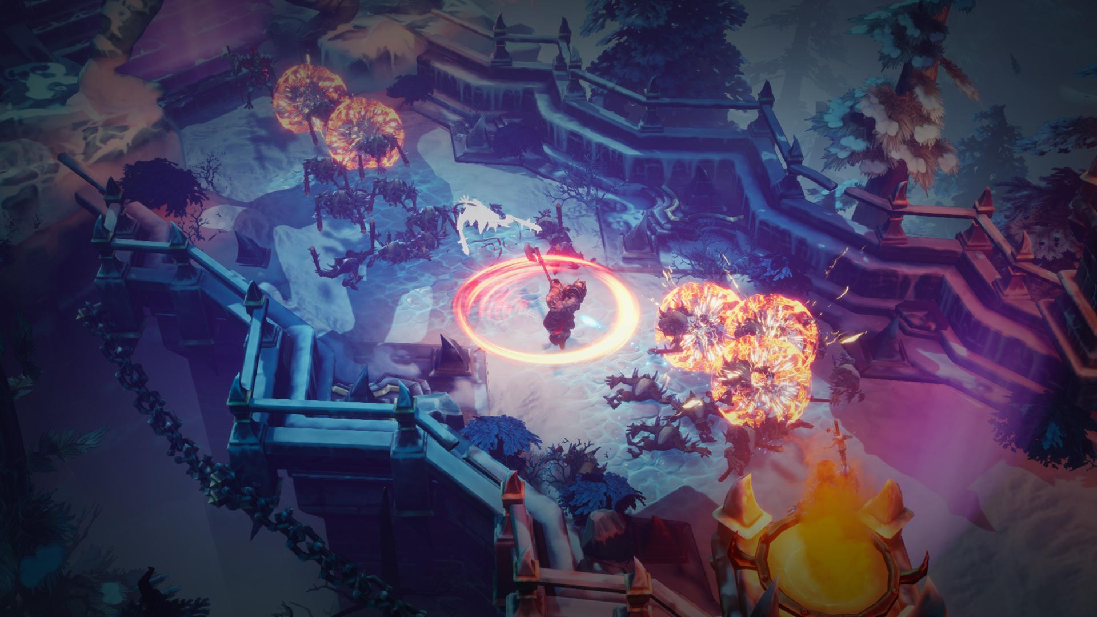

**Genre:** 3rd person action RPG, single player, fixed camera (?)  
**Target Audience:** 13+, fans of diablo and sci-fi RPG games.

**Controls:** Mouse and Keyboard

**Thematic Setting:** Medieval / Fantasy / Sci-Fi / Time travel

**Tech Stack:** Unity 2019.3, Asset Store, Blender

**Platform(s):** PC

**MVP Game Moment:** 2 minutes of movement from places a to b, fighting with 3 or 4 enemy types.

**Game Summary:** You start up outside in medieval village, but you don’t look medieval; how did you end up here and why do you dress like this? Let’s go to the village and find out what we can.

Project “mfRPG” is about finding the truth about where did you come from and how to get back there. To do that you have to find clues while fighting your mysterious nemesis and his/her minions. Each level is set in a different era, so at the end of each level you find a clue that lead you to fight your mysterious nemesis and then find a portal that takes you to a different level / era.

**Core Player Experience:** Cute, witty, funny, mysterious adventure

**Central Story Theme:** Time travel, find your way back home / time.

**Design Pillar:** Meeting people (npc) from different eras, finding clues, mystery.

**Remarkability:** Different era maps and futuristic stuff meets ancient time.

**Anticipated Steam Early Access Launch date:** Early 2021.

**Feature Development Priorities:**

* Real time combat
* RPG stats and levels (upgradeable)
* Level building and game progression
* Branching dialogue system
* Inventory system, loot, usable items
* Ranged weapons
* Abilities (with trees for variable player builds)
* Player choices matter in future game actions / conversations / options.

**Reference Games:** Knights of the old republic, Diablo, Torchlight, Torment Tides of Numenera, Last Epoch